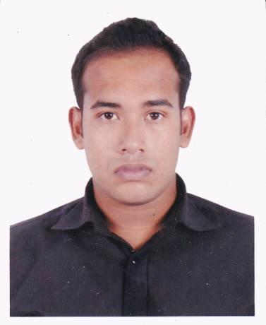**Curriculum Vitae**

**OF**

**Rafat Alam**

**Contact Details:**

2-B/8, Pallabi, Mirpur-11.5,

Dhaka-1216.

Cell: 01681617851, 01552345563

Gmail: [alamshabab52@gmail.com](mailto:alamshabab52@gmail.com)

***CAREER OBJECTIVE:***

I'm looking for such scope and opportunity to express my creativity & work with pleasure, sincerity and honesty that will prove potentiality creativity in a competitive environment with a view to achieving goals, which could be a skylight to prove myself.

***EDUCATIONAL QUALIFICATION:***

**B.B.A (Hon's')**

Institute Name : Dhaka Commerce College

University : National University

Subject : Finance & Banking

Passing Year : 2019

Result :3.06 [out of 4.00]

**Higher Secondary Certificate (H.S.C)**

Institute Name : Dhaka Commerce College

Board : Dhaka

Group : Business Studies

Passing Year : 2014

Result : 4.30 [out of 5.00]

**Secondary School Certificate (S.S.C)**

Institute Name : West End High School

Board : Dhaka

Group : Business Studies

Passing Year : 2012

Result : 4.06 [out of 5.00]

***COMPUTER KNOWLEDGE:***

Having basic computer knowledge on MS Word,

E-mail & Internet Browsing.

***PERSONAL ATTRIBUTES:***

* Strong communication, interpersonal and analytic skills.
* Ability to work under pressure to achieve targets within deadlines.
* Easily adapt to a dynamic environment.
* Work with dedication, commitment and integrity

***LANGUAGE SKILLS:***

Fluent in reading, writing, speaking and listening both

in Bengali & English

***HOBBY:***

Traveling, Leistering, Music, Reading Books.

***PERSONAL DETAILS:***

Name : **Rafat Alam**

Father's Name : Jahirul Alam

Mother' Name : Mahbuba Begum

Date of Birth : 6th October, 1995

Permanent Address : Vill: Hazibari Uttar Kachichira, P.O: Pukurjona,

P.S: Patuakhali, Dist: Patuakhali, Div: Barisal.

Present Address : 2-B/8, Pallabi, Mirpur-11.5, Dhaka-1216.

Religion : Islam (Sunni)

Marital Status : Single

Sex : Male

Height : 5′-9′′

***REFERENCES:***

|  |  |  |
| --- | --- | --- |
| 1.  Sifat Bin Momin  Founder & President  dealon.com  Dhaka.  Cell: 01841-174155 |  | 2.  Dil Nasrin Khan  Lecturer  Shahid Police Smrity College  Dhaka.  Cell: 01937085698 |

***STATEMENT:***

I do hereby certify that all information stated in this resume is true. I authorize the authority to verify the information provided in the resume.

_____________________________

Signature

Date:

Rafat Alam